What is going on here?
The Vigil and Elevation of Oswyn Swann.
This is a play in three parts. The first was Monday of War Week at Pennsic XLIX. Geoffery Swann, Oswyn’s father, gains a Writ from Queen Elizabeth in 1590 to distribute imported vinegar. The importation of vinegar would fall under the control of the Company of Vintners as it is largely a wine product. Oswyn takes the first barrels of that shipment and distributes samples. It is a success.
The second is the Vigil. It is approximately 5 years later. Geoffery passed away about 2 years ago. Today is Oswyn Swann’s (not Sean’s) 50th birthday! Oswyn is sitting in the Great Room of Swann Manor outside of Bath, receiving guests.
The third is the Elevation. Three more years have passed, and Oswyn is made the new Master of the Guild of Vintners. It is a festival day by royal decree so many of the notables of the Realm are dressed fancifully for the day.
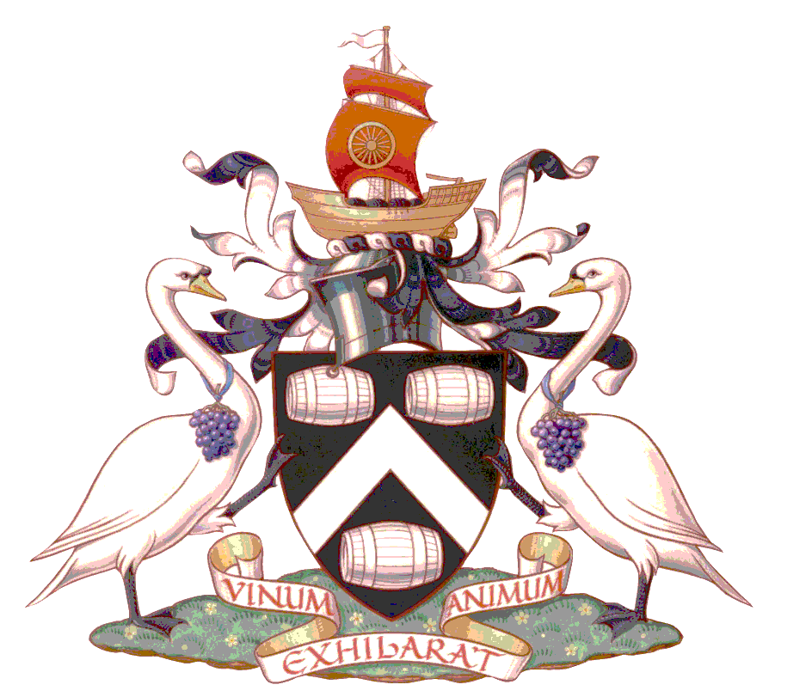
The elevation ceremony for Oswyn to the Lauralate will be mainly the traditional ceremony with some changes.
To the left is the heraldry of the Worshipful Company of Vintners. This is one of the 12 Great Companies of London. Officially founded on July 15th, 1363, the Guild likely existed prior to this, potentially even before the Norman Conquest, and still exists today. The Company of Vintners ranks 11th of the Twelve Great Livery Companies by the order of precedence established in 1515.
Amongst the notable events for the Company is the Feast of the Five Kings. According to tradition, in 1363, Sir Henry Picard, Master of the Company, entertained Kings Edward III of England, David of Scotland, John of France, Waldemar of Denmark, and Peter of Cyprus. This results in the Toast to the Company “The Vintners’ Company, may it flourish root and branch forever with Five and the Master.”
I did not consciously choose the swan as my device to match the Guild heraldry. It is a happy coincidence. The Vintners are also allowed to participate in the Swan Upping. There are only three official entities that were allowed to participate: The Monarch, the Vintners’ Company and the Dyers’ Company. Originally to determine who owned which swans for feast purposes, it is now a conservation measure to check the swans’ health. Also originally, the swan’s beak was “nicked” to show it was tagged. Now, it is by small colored rings around their feet. The “nicking” became “necking” in speech, giving rise to the pub named “The Swan with Two Necks.”
Each July, the Company choose a new Master and follows a procession. The Wine Porter would sweep the path ahead of the rest of the Company, using a birch broom. The new Master and the Wardens would carry nosegays, bouquets, largely to help with the smell of the city and river. The walk from the Guild Hall to the Church of St James Garlickhythe, near the docks where garlic and wine from France would be unloaded. Modernly, they still dress in their fur-lined gowns and Tudor hats for this procession.
I have incorporated the sweeping and bouquets to this ceremony to give the illusion of what is happening.

