Making a Persona – Oswyn Swann
By Oswyn of Baðon mka Sean Wilson oswyn969@gmail.com
Shire of Caer Gwyn, Middle Kingdom, Known World
Table of Contents
Introduction 1
Skills Learned 1
The Name 2
The Profession 2
The Vinegar 3
Making the Vinegar 4
The Barrels 5
Barrelheads 5
The Wheel Barrow 7
The Clothes 9
The Banners 10
The Store/The Inn 12
The Ciders 12
References 12

Introduction
I have had the name Oswyn Swann registered for a few years. He is my second persona, and I knew I wanted a second persona to explore later period items. I knew he was a merchant, a distant relative of my main persona, from Bath, and either Tudor or Elizabethan. I knew little else.
However, once I started finding a few things out about my hobbies, his persona came together. This document tries to document and explain who Oswyn Swann is and the steps I took to define him.

Skills Learned
For this project, I learned several skills which I had not tried before.
- Pyrography
- Painting with oils
- Sewing rolled hems
  - Then used those skills to sew medieval hoods and applique (not related to this project)
- Research on the Worshipful Company of Vintners
- Making ciders
- Making shrubs
- Making wines
- Making a significantly larger volume of vinegar than previously attempted
- Making banner poles
- Assisted with making a wheelbarrow (COVID 19 interfered with me learning to do this on my own)
- Learning more about barrel aging and conditioning
  - Used this knowledge to age ciders, various vinegars, establish a solera for sherry vinegar, aging vanilla extract, and aging liquors

The Name
My main persona is Oswyn of Baðon. The name Oswyn is timeless. It goes all the way back from Anglo-Saxon times to the present. The Os- protonym has some roots in the area. The Kings of the Hwicce had Os- names. Bath was the extreme southern part of the Kingdom of the Hwicce. I chose a swan as part of my device, so I took the name “Swann” for my late English persona.
Oswyn Swann is a descendant of Oswyn of Baðon. The ancestral estates would have been part of the initial establishment of the burh of Bath. Oswyn’s family were reeves. As Bath would be reincorporated over the years, the Swann family would have been part of it.

The Profession
I initially had a large problem figuring out what Oswyn Swann did. He was initially a wine merchant. Then he was going to be a stationer/paper maker. But when I learned I didn’t really like making paper, I needed something else.
I found this etching in Vinegar, The Eternal Condiment [1]. It is Pierre Brebiette’s Le Marchand de Vinaigre circa 1634 [2]. A larger version is at the end of this document.
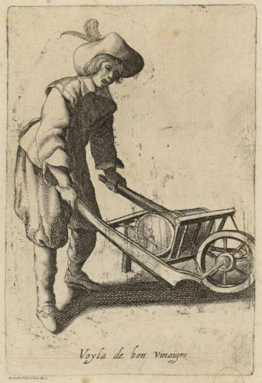
As I had been making vinegar for ~2 years at this point, it suddenly occurred to me that Oswyn Swann could be a vinaigrier. Most of this would be imported. In the 1380, the Orleans Process was developed in Orleans. Vinegar went from a cottage industry to a large scale enterprise. Ale and cider vinegar was still made in England and was mostly local. But wine vinegar was a major export with wine from France to the rest of the world. The industrialization of vinegar also allowed for the industrialization of mustard.
Oswyn Swann therefore runs a vinegar import business. I have commissioned a fake writ from the Queen giving the Swann family the exclusive right to import and sell vinegar in the West of England as part of the charter than incorporates Bath.
According to The National Trust of the UK [3], imported vinegar from France would come in tuns (~252 gallon barrels). Wine from France ran ~3 pound per tun and vinegar was a bit cheaper. Using 3 pounds per tun, 252 gallons per tun, 240 pennies per pound, and modern equivalents, an ounce of imported vinegar would run about a 0.022 penny per ounce. The average maidservant made ~3 pounds per year. Imported vinegar was affordable but local vinegar from ciders or ales would have been much cheaper. For “selling” purposes, I will be canting, “vinegar, a ha’penny per pint!”
Vinaigriers in England would have been regulated by the 12 Great Companies in London, specifically the Worshipful Company of Vintners [4]. Vinegar is primarily a wine product, so the Vintners control it.
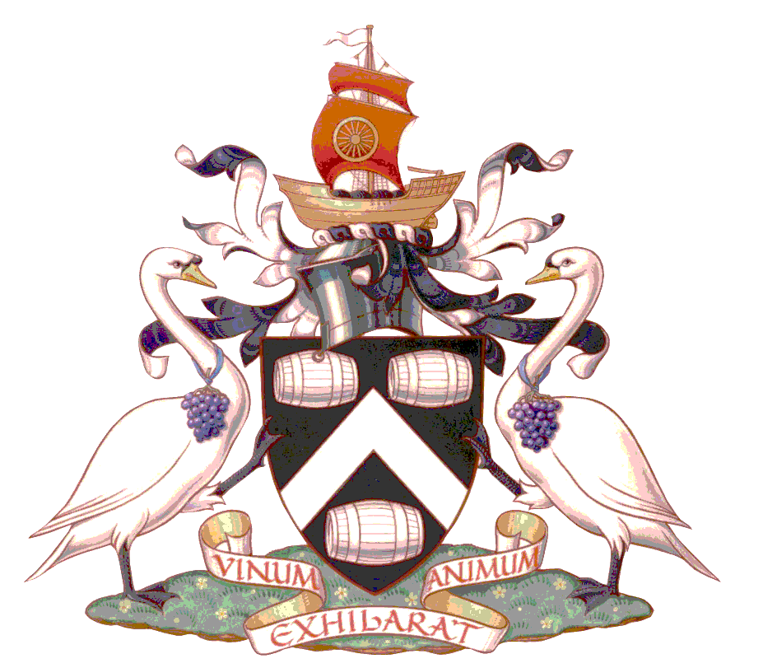
The Worshipful Company of Vintners are one of the two Guilds, along with the Crown, involved with the swan upping in London. The swan upping is where the Guilds and the Crown would divide the ownership on the swans on the Thames. Hence the swans as supporters on the Guild Coat of Arms. It is a happy coincidence that with my own device and Oswyn surname include swans.

The Vinegar
Our word vinegar comes from the French, vin aigre, sour wine [5]. Making “sour wine” is not hard as it will happen all by itself. Vinegar is different from verjuice which is the unfermented juice of sour grapes, or immature grapes.
Vinegar dates back to pre-historic times. I don’t think we will know exactly where and when it was discovered but it is at least as old as brewing as the two processes are related. Supposedly, the Babylonians used vinegar as a cleaning agent as early as ~5000 BC. Ancient Egypt has evidence of vinegar as early as ~3000 BC. Ancient China has evidence of vinegar as early as ~1200 BC [6].
According to multiple sources,
“the Pinot Noir grape is one of the earliest varieties of grape to be cultivated with the purpose of making wine. As early as the first century AD, ancient Romans were producing wine using the Pinot Noir grape. After invading Gaul (France), the Romans noticed that the Gallic tribes were drinking a wine stored in wooden casks and bred from wild native Pinot Noir grapes, and were surprised by the unique flavors. It is said that Roman emperors coveted this wine for more than 300 years.
When the barbarian horde swept through France centuries later, wine making was still a priority. Production was handed down to the peasants, who worked for wealthy landowners.
But the single most important reason that Pinot Noir survives to this day has to do with Catholic monks. Pinot Noir was the wine of choice for use in their sacraments, and the approval of the Church was more than enough to garner mass appeal. By the sixth century AD, Burgundy was divided into multiple vineyards, which were all owned by regional churches.” [7]
There are two methods of making vinegar in Classical and Medieval times. The first is the easiest. Just leave a fermented liquid (typically a wine, ale, or something below ~20% alcohol) out in the air. Wild acer-bacteria will colonize the liquid, turning the alcohol into acetic acid. The other method is known as the Orleans method. In this method, you lay a cask on its side. Then drill air holes in the sides. Then add wine to the cask until just below these airholes. A vinegar mother (a jelly like substance containing cellulose and bacteria that can help to catalyze vinegar development) can be added if you have one, otherwise wild bacteria will enter with the air. Stop the airholes with cloth to allow air in but not insects and other contaminants. After several months, you will have vinegar. About 80% of the cask is typically drained to either use/sell right away or age further. Then more wine is added to the cask and the process allowed to continue. Acidity of up to 10% can achieved with this method [8].

Making the Vinegar
I purchased a wine kit from Great Fermentations and followed their instructions. After several weeks, I had 6 gallons of Pinot Noir wine. I then converted it to vinegar via the Orleans Process 2 gallons at a time. The finished vinegar was then put in a 20 liter toasted oak barrel for ~1 year to age.
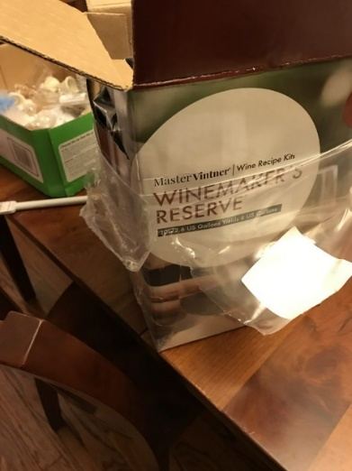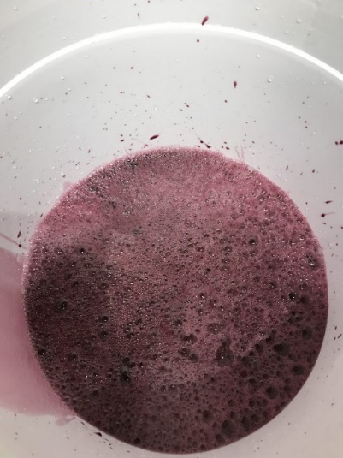

The Barrels
While I toyed with learning to be a cooper, that really wasn’t practical with my time and abilities. I purchased several barrels, ranging from 1 L to 20 L from Oakbarrelstld.com. These are made from American Oak. I have used both steel and galvanized hoops.
I settled on 20 liters as that was the largest barrel they sold, and it was likely to be the largest amount I could reasonably make at one time. In period, tun/tonne barrels would have been possible and probable. I just can’t handle anything of that size. That being said, the etching above has a fairly small barrel. Given the dimensions of myself and the wheelbarrow, this is likely close to 20L/5 gallons.
On a side note, I have used this information to start a close-to-true balsamic process.
True balsamic vinegar is expensive. Modernly, it is a protected product of the Modena region of Italy. It is made exclusively from a reduction of pressed Trebbiano and Lambrusco grapes, aged for at least 12 years in a series of specific wooden casks, ideally in a specific series of caves in Northern Italy [9].
The word “balsamic” does not appear in the historical record until 1747 AD as part of the Duke of Modena’s inventory. However, vinegar from the region does figure prominently going back to 1046. Monk Donizone in the Vita Mathildis mentions a barrel of vinegar from this region being given to Holy Roman Emperor Henry II. It was given to the Emperor by Bonifacio, Matilda of Tuscany’s father. From circa 1228 through 1598, particular mention is made of barrels of special vinegar, sometimes called the Duke’s vinegar in inventory lists and ducal writings. Again, the word balsamic is not used at this time but given the region the vinegar came from and its importance as an imperial gift, these authors believe it was either the same as our modern balsamic vinegar or at least proto-balsamic [10].
For this “balsamic” process, I can get 6 gallons of Lambrusco grape juice from Italy. First, I will boil that down as mosto cotto, and then turn it into wine. I do not have access to various wood barrels but I can age in American Oak barrels and allow the evaporation to occur. I estimate this process will take ~3.67 years and yield 2 L of “balsamic” vinegar starting with 20 L of grape juice.

Barrelheads
In period, barrelheads would likely have not been marked. I wanted to mark them though, as I think it is interesting and it helps label the product. Like in period though, I wanted to reuse my barrels if I could. I purchased some wooden blanks and used Velcro dots to attach the blanks to the barrelheads.
For this part of the project, I learned to do pyrography from David of Lochmorrow and learned to do some painting by my own trial and error.
I started with a blank disk. I then printed out the design and used graphite paper to transfer the design to the blank. I then used an electric wood burner to burn in the design. I then painted the design for more permanence.

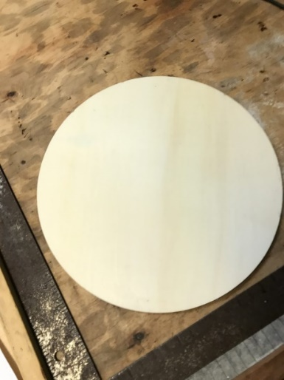 |  | 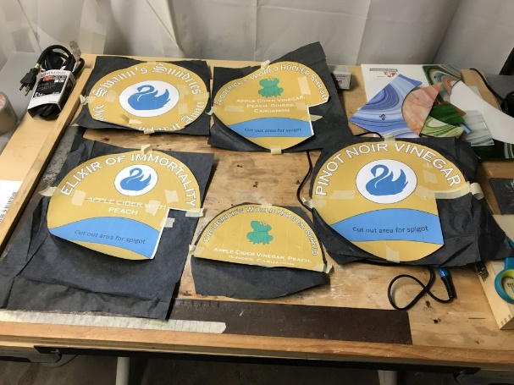
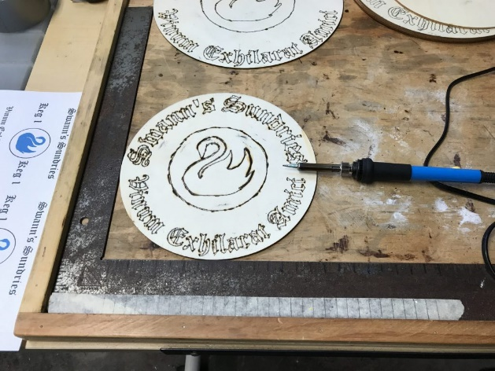

Cutting these thin disks did not work for the barrel “fronts”, where the spigot was. I fastened a small chalk board to label those.
I did discover that this was hard on my hands. I opted for a direct transfer method for my barrels at home. For this method, I used acetone to transfer the toner from the paper to the wood, and then painted the images.
For the barrel in this display, I used carbon paper transfer, pyrography, and paint. A few of the barrel heads are my own efforts. I did enlist the help of a much more skilled painter for the rest though.

The Wheel Barrow
This was the major part of the project. My friend works for a company that makes museum exhibits and is a skilled woodworker. The original plan was for him to supervise me as we made this. However, COVID-19 had other plans. I did help and do some tasks, mostly sanding and shaping. Much of the rest of the work was his efforts though.
We start with the wood cut for reference. The wheel is particularly nice and the centerpiece of this whole project. I played no role in making the wheel. The rails as well are significant. I did some sanding on the rails but the bulk of that was my friend. I did much more work on the basket and backstop.
I also had needs that a medieval vinegrier didn’t. My cart has to come apart and be transported places. To hide the modern bolts, we used rare earth magnets and wood to “fake” a mortise and tendon joint.
The vast majority of the cart is wood but we opted for a steel axle and iron cotter pins to complete the look. See the next page for the photos.

 | 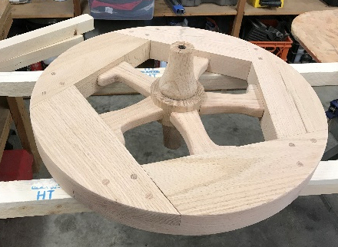 | 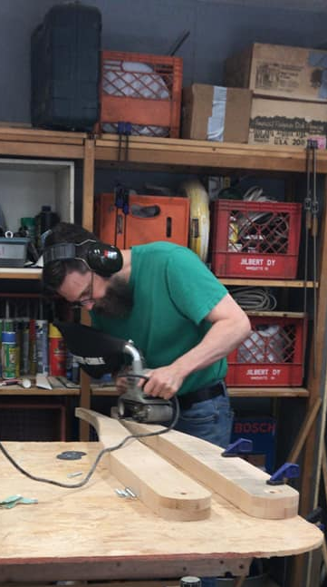
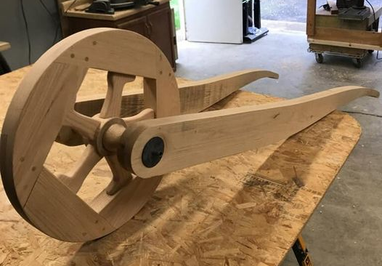 | 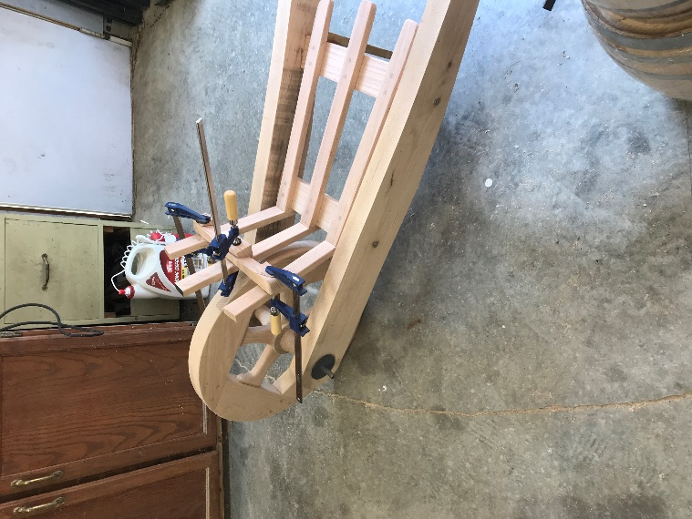 | 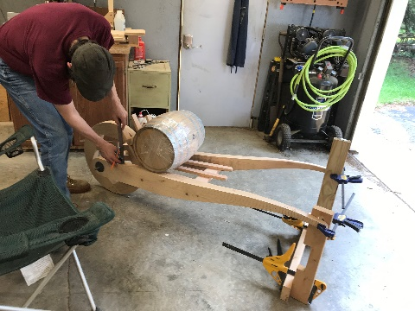
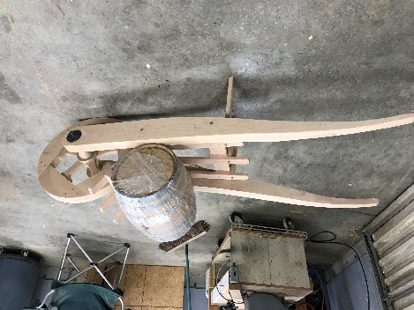 | 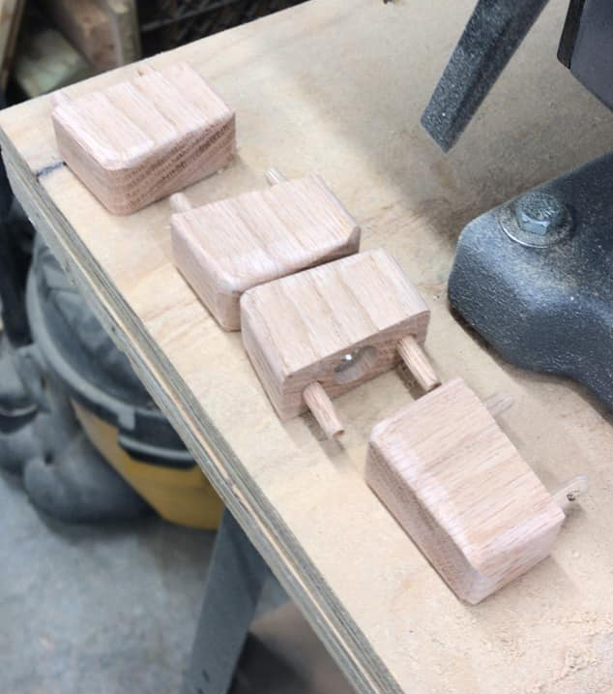 | 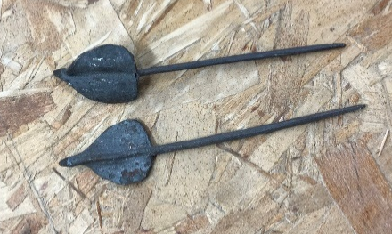

The Clothes
The photo on the left is my old Ren Faire outfit. That was ~30 lbs ago and obviously, the doublet doesn’t fit any more. So I needed to get new clothes to make this work. On the right, I have a new green doublet and a new flat cap. The bottom photo shows some options I have: rust pants, olive pants, brown hose, and several pairs of socks.
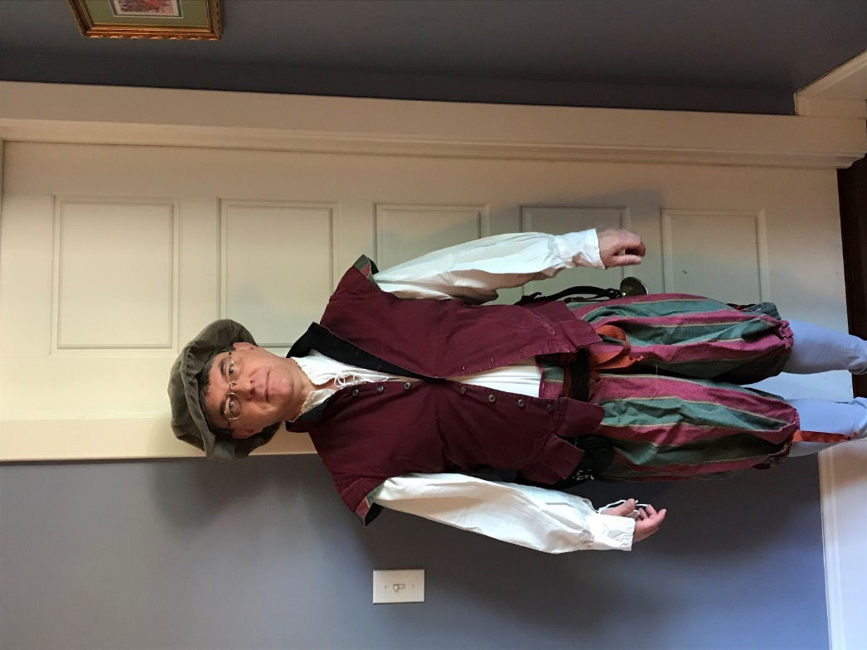 | 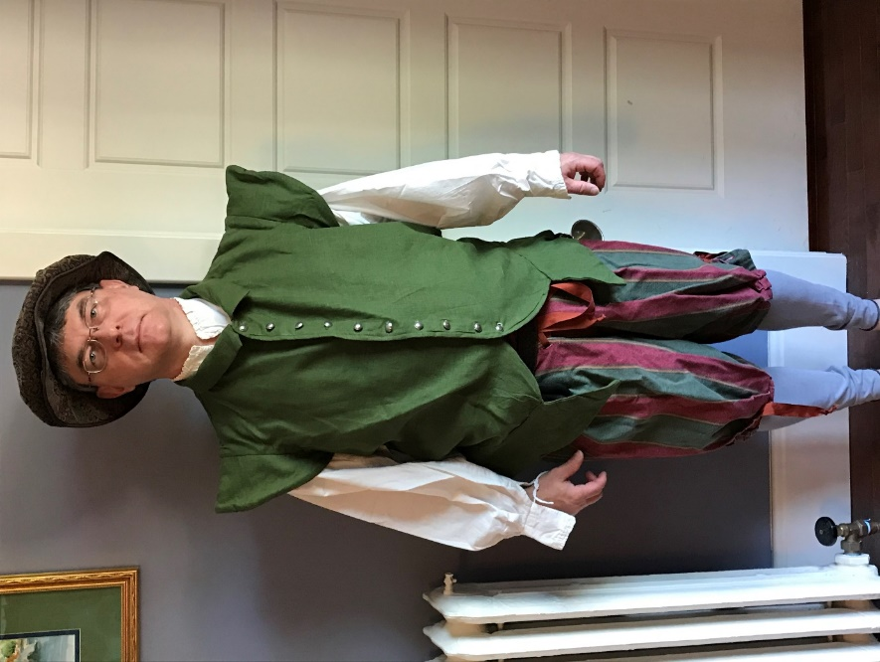
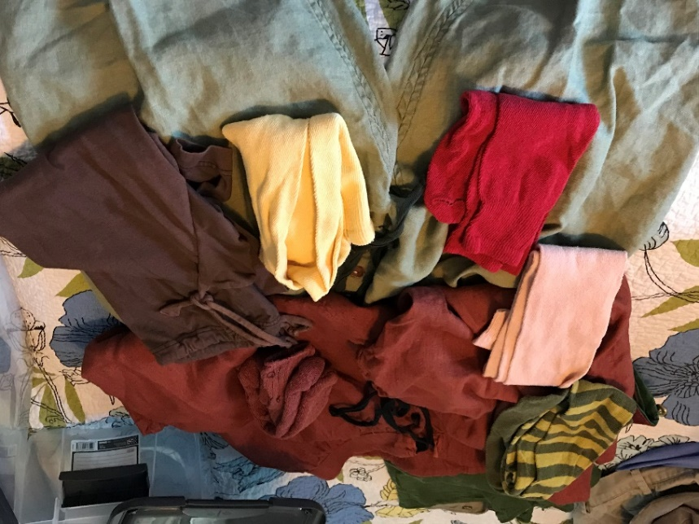

The Banners
To advertise what I was doing and to decorate, I wanted some banners. I needed a variety of banners. These are modernly printed through Spoonflower.
The two smaller ones are intended to be flown on the wheelbarrow. The two longer ones might be in my camp or tavern. The middle one is my A&S motto, as I often do glass work. Literally, it is “blood makes art.” The intended meaning is “It isn’t art until you bleed on it.” That is just awkward in Latin.
The other motto, Vinum Exhiliarat Amici, is a pun off of the Worshipful Company of Vintner’s motto. It means “Wine/alcohol// brings joy/cheers // friends” This would be the motto of the Blue Swan Inn, my tavern.
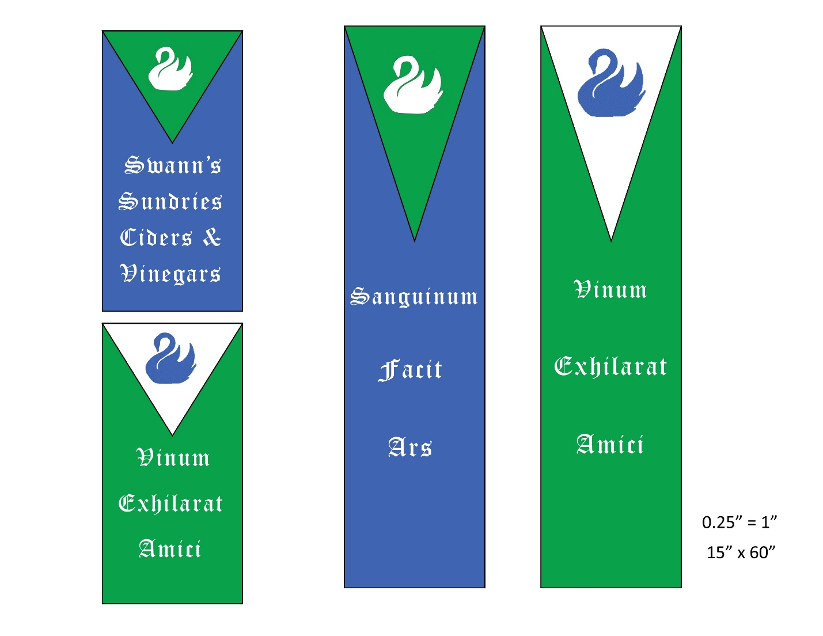
I worked with a friend to make banner poles.
To make the banner stands, we cut 2 x 4s to lengths to make the bases and glued a small block to give more depth for the pole. I rounded the corners with a belt sander. We also glued feet to part of the bases. For the poles, I used a palm sander to make the one end slightly less thick to fit in the holes. Holes were drilled in the base. We cut notches in the uprights and drilled holes in the cross pieces. A string will go through the holes of the cross braces and rest in the notches. The banners will hang from clip rings on the cross pieces.

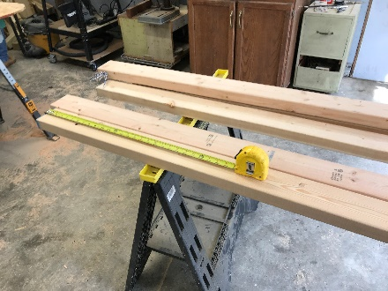 | 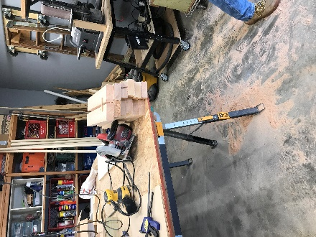 | 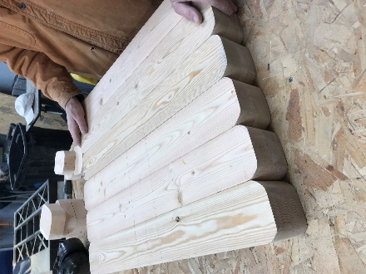
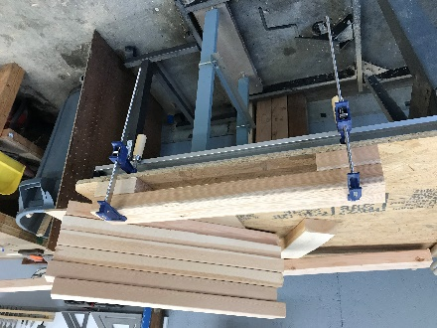 | 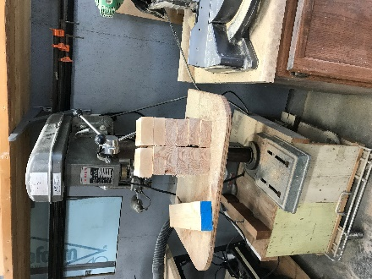 | 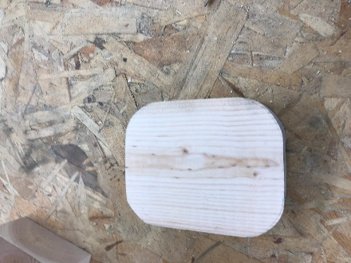
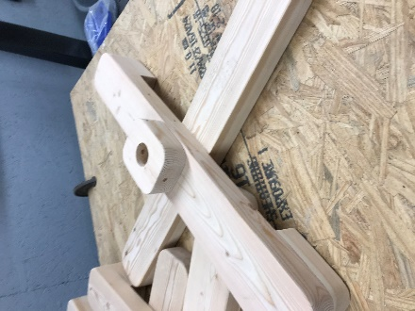 | 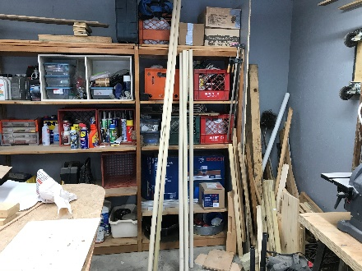 | 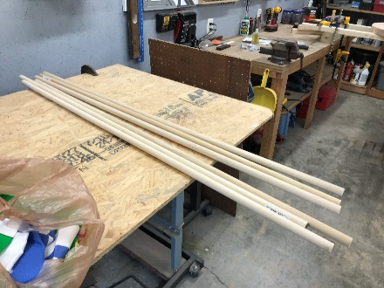
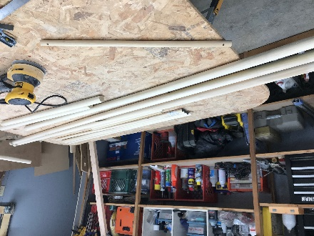 | 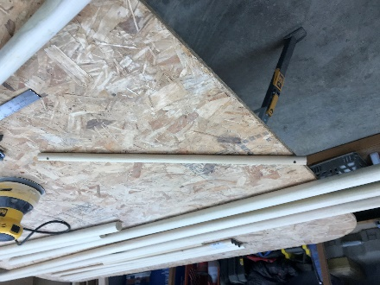

The Store/The Inn
I need a place to sell and distribute my vinegars and ciders from. I started registering a household and badge to accomplish that. As of 4/13/21, the household name of The Blue Swan Inn was approved. The badge was not but I will continue to use it unregistered. The badge is a Blue Swan on a silver plate. I will sometimes put it on green background but sometimes not.

The Ciders
While this persona play focuses on Pinot Noir vinegar, apple cider vinegar is easily available, both in period and modernly. Apples are much easier to grow and process into alcohol than grapes. My first “step back” was to make my own ciders. I initially made them with apple juice concentrate. I now make them with sweet cider sourced from my local orchard. Plans are made to plant apple trees and juice those apples to make cider and then vinegar.
I do and have make my own meads and wines. While I would love to have bees and grapes, it is not practical to have those where I live. For my wines, I order wine grape juice from Great Fermentations in Indianapolis and make my wine that way. For meads, I will often buy bulk honey from various suppliers.

References
[1] Reginald Smith, Vinegar, The Eternal Condiment, Spikehornpress, 2019, p
[2] Pierre Brebiette, Le Marchard de Vinaigre, house in the Musee Carnavalet, Histoire de Paris. Inventory # G. 12550.
[3] https://www.nationaltrust.org.uk/tudor-merchants-house/features/what-could-you-buy-at-the-tudor-merchants-shop
[4] https://vintnershall.co.uk/
[5] Melitta Weiss Adamson, Food in Medieval Times, p 28
[6] Abu Ali al-Husayn ibn Abd Allah ibn Sina (Avicenna), al-Qanun fi’l-tibb (Canon of Medicine), translated by Gruner, Oskar Cameron, 1930 London, reprinted 1973, Ames Press, NY.
[7] http://www.pinot-noir-wines.com/ with additional verification from http://www.thewinecellarinsider.com/wine-topics/wine-educational-questions/grapes-for-wine-making-flavor-characteristics-explained/pinot-noir-wine-grapes-flavor-character-history/
http://vinepair.com/wine-blog/the-king-of-burgundy-the-surprising-history-of-pinot-noir/
http://www.uncork.biz/tidbits13.aspx
[8] Maggie Oster, Herbal Vinegar, p 3-5. However, many other sources make the same claims but none of these sources cite their original reference.
[9] Consorzio Produttori Aceto Balsamico Tradizionale di Modena". Archived from the original on 13 April 2010. Retrieved 2010-03-25.
[10] Giudici, Paolo, Federico Lemmetti, and Stefano Mazza. Balsamic vinegars: tradition, technology, trade. “Chapter 2: History of Balsamic Vinegar”, Cham: Springer, 2015.

