Barrels and Barrel Aging
By Oswyn of Baðon / Oswyn Swann mka Sean Wilson; oswyn969@gmail.com
Shire of Caer Gwyn, Middle Kingdom, Known World
Contents
Barrels and Barrel Aging 1
Introduction 1
Ancient History 1
Classical Period 2
Medieval Period 2
Modern barrels 2
Care and upkeep of the barrel 3
Aging liquors 3
The Solera 4
References 4

Introduction
In the Middle Ages, the barrel was ubiquitous. It was the container for wet goods, dry goods, bath in, measuring things, crossing rivers and much more. The cooper was a man who always had work. Yet, in our modern era, barrels are largely missing but still exist in the craft brewing industry. This class is very European centric but so is the barrel in many ways.
I will be saying “barrel” a lot. Actually, the proper word is cask. A barrel is a specific size of cask and therefore came to be the word we tend to use modernly.

Ancient History
There are tomb paintings from Ancient Egypt that show the use of barrels. Around 2600 BC, we have an illustration of a wooden tub made of staves used to measure wheat [1]. Around 1900 BC, we have another illustration of a tub used in the grape harvest [2]. These tubs may have been made with palm wood, bound with reeds.
We later find Iron Age finds in Europe of tubs and wooden staves.

Classical Period
In many ways, the Classical Period is one of stone. The Greeks and Romans built in stone and marble. Amphorae were the common means to store and transport goods. Barrels also existed but it wasn’t until the Romans move into the oak forests of Gaul and Germania that they become more common.
Pliny the Elder reports that there existed three kinds of cooperages in Gaul, ordinary coopers, wine coopers, and large-cask coopers.
The Romans even used casks for military purposes, filling them with pitch and hurling them into sieges. Pontoon bridges were another use.

Medieval Period
If the Classical Era is one of stone, the medieval period is one of wood. The various Germanic tribes coming into central and northern Europe preferred working in wood, as evidenced by their architecture.
Here barrels are everywhere. We get a variety of sizes as well, from the tun (~252 gallons) all the way down to the pin (~4.5 gallons). The actual measure of many of these would vary over the centuries before the tun is standardized at 252 gallons. Which would make this possible:
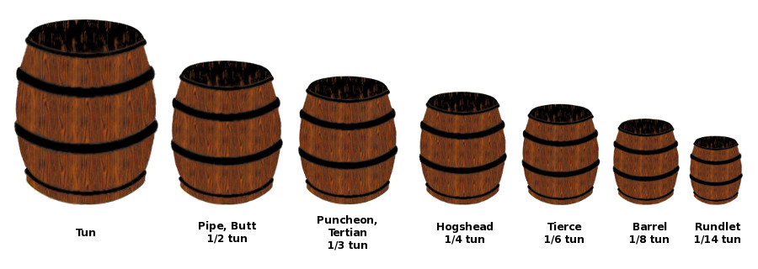
The standard barrel as a measure would become 36 imperial gallons. Smaller casks such as the kilderkin was ~18 gallons, the firkin at ~ 9 gallons, and as mentioned before, the pin at 4.5 gallons.

Modern barrels
There are two modern industries that still use wooden barrels, the traditional French wine industry and the Bourbon industry. In specific, the bourbon industry has led to a resurgence in coopering and the use of barrels in brewing.
Bourbon, by legal definition, must be aged in new oak casks. What to do with those casks when you are done? Breweries discovered they could buy them cheap and aged their beers in them, adding a bit of the bourbon flavor to the brew.
There are several cooperages that make barrels for the hobbyist and industry. I buy mine from oakbarrelltd.com.

Care and upkeep of the barrel
The first thing you need to do with your barrel is clean it out. There is likely loose wood in there. Partially fill it with water and flush as much of the wood chips out. They won’t hurt anything in the spirits. They might clog your spigot though.
Then hammer in the spigot and fill the barrel with water. Some suggest that this must be hot or nearly boiling water. Hotter water does seem to help particularly leaky barrels. I have had good luck most of the time with lukewarm tap water. The point is to ensure that the wood swells to make a water proof seal. At this point, the barrel MUST have liquid it forever or it will become useless. Don’t swell a barrel until you are ready to use it.
There can be the thought to deny the angels their share. The evaporation of whatever is in the barrel is called the angels’ share. Do not wrap the barrels to try to prevent the evaporation. The liquid will just sweep to the outside of the barrel, have nowhere to go, and warp the outside of the staves. Depending on what the liquid is, it can corrode the hoops as well. It is very unattractive. With enough corrosion and warping, it can make the barrel unusable.
Once a barrel as been used for vinegar, it should not be used for anything else. Low proof alcohols will most likely turn to vinegar. Higher proof alcohols will take on a vinegary flavor. The acer-bacteria will colonize the wood and only sterilization will remove it.
The use of SO2, through sulfur strips or gas, can be used to try to sterilize a barrel that has had its interior expose to air for a significant time. I have not tried this.
Keep full of water, the barrel should be usable for a long time. It does depend on what you are using it for.

Aging liquors
Many liquors can be or have been aged in casks. Many wines, sherry, many whiskeys, rum, gin, bitters, syrups, and vinegars.
Many of the casks that were used or are currently are used are toasted. The charring of the interiors helps to remove a “resiny” flavor by altering the chemicals in the wood. Tannins and vanillin in the wood is now more readily available to leach into the liquid. The charring can also color the final liquid.
The standard wisdom is for hogshead sized barrels, that ~3 uses are possible before the barrel goes “neutral.” That is, all of the flavor compounds and color have been leached out. The barrel can still be used for storage but it will not develop these additional flavors. The liquid might develop more complex flavors still through oxidation though.
Smaller barrels will have fewer uses before they go neutral. This is a function of time though. Several three month ageings might be possible, whereas only a small number of 2-3 year ageings can be possible.
When liquors refer to years of age, they mean in these larger barrels. How quickly these flavors enter the liquor is largely a function of surface area and diffusion. Therefore, smaller barrels have a shorter “year” than larger barrels.
Temperature also plays a role. The warmer it is, the shorter the “year.” Hence why rums are aged less than scotch and why tequila is barely aged at all.
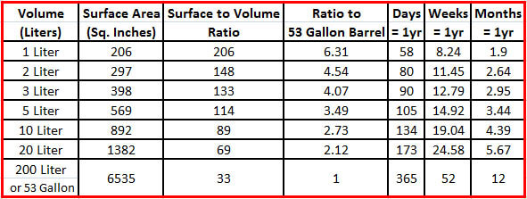
From redheadoakbarrels.com
As most hobbyist will be using between 1 and 20 liter barrels, frequent tastings are advised. When it gets to the flavor you like, you should probably remove it.

The Solera
The solera process is definitely outside of period, with the first mention in 1760. But there is nothing inherently modern about it. Amongst the products renown for being produced by the solera method are sherry and sherry vinegar. Both of those products date back to the Classical Period but as mentioned, the solera method is likely much more modern.
In the solera method, product is a mix of different ages of liquids to make a blended product. The final product is extracted from the “ground level”, the solera is Spanish. Typically, about 1/3 of the product is taken out. Casks are then filled from the casks in the criaderas above them. Thus, the product is a blend of different aged liquids.
In my solera, I have 3 casks and I am making 2L of Sherry vinegar at a time. The oldest cask has aged 18 months. The middle cask is aged 12 months, and the top cask is aged 6 months. Every six months after that, I take 1L out of the solera, and fill down the line adding 1L of “new” vinegar to the top most cask. The end result vinegar is the equivalent of 9 years 1 month. Almost the same age as Vinegre de Jerez Gran Reserva (10 years in 53 gallon wood).
There is nothing modern about this and Medieval people could have done it. The process is a natural outgrowth of the balsamic process where the vinegar is aged in different casks of different woods over time. The difference being in the balsamic process, the casks are not refilled. The final vinegar is all the same age. The solera process is used for whiskeys, port, rum, sherry, vinegar, and many other liquids where having a different age is wanted to add complexity to the product. Some soleras vary the wood of the cask between layers to add even more complexity.
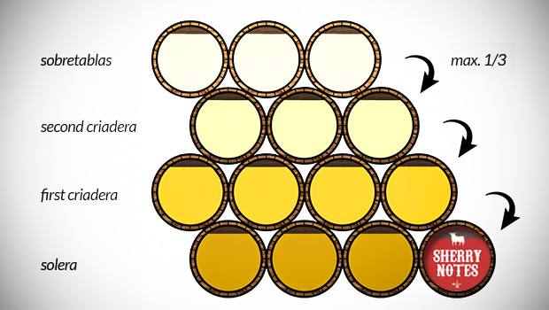
Solera system [3]

References
- Kenneth Kilby (1989), The cooper and his trade, Fresno, California, Linden Publishing, p.91. ISBN 0-941936-16-3
- ^ Diane Twede, "The cask age: the technology and history of wooden barrels", Packaging Technology and Science, 2005, 18, p.253
- https://www.sherrynotes.com/2013/background/sherry-solera-system/

