What is going on here?
Two things: a medieval experience and persona play.
My second persona is Oswyn Swann (pleased to meet you!). I have made him into a vinaigrier, a seller of vinegar. For reference, my primary persona is Oswyn of Baðon.
The photo below is an etching from 1630. It is a little out of period but it is very reasonable that this is how vinegar was sold from about 1380 to 1740 in Europe. Why? 1380 is when the Orleans process is developed in Orleans France and vinegar become “industrial.” ~1740 is when vinegar is first sold in bottles. The photo below certainly represents how things probably worked in towns and cities in late period and mostly likely much early.
The seller would go door to door. If you wanted vinegar, you flagged him down, filled your vessel from the cask, and paid whatever the going rate was.
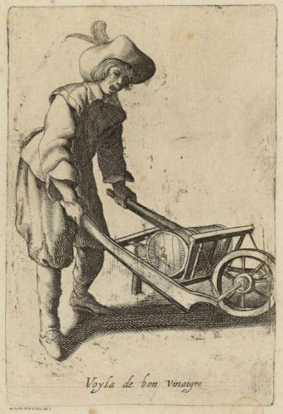
Estates, manors, and royalty would have their own contracts and would get the vinegar in casks and cellar them like wine.
Rural communities likely made their own vinegar as needed. It is pretty easy.
I will try to stay in persona and likely fail If you are confused about what is persona and what is “real”, just ask or do an actor’s aside (place your hand aside your mouth).
If you have feedback, positive or negative, about this experience, please feel free to contact the following:
Laurel: Master Gunnarr Alfljot OL (MKA Jim Planting) nattravnet@aol.com
Pelican: Master Wilhelm Michalik OP (MKA Michael Mihallik) uberpessimist@gmail.com
TRM Middle Kingdom: trm@midrealm.org
TRH Middle Kingdom: trh@midrealm.org
I am also known to many Laurels and Pelicans in the Middle Kingdom. They will likely be willing to pass on any information to my Peers and as needed to me.
What you have is this: Pinot Noir Vinegar. The Pinot Noir is from a commercial wine juice kit, Master Vintner Winemaker's Reserve Pinot Noir Wine Recipe Kit. I then made it into wine in a 6 gallon ale pail and VVV yeast. It fermented for yyy weeks in the primary then zzz weeks in the secondary.
After that, I added my 200+ year old mother of vinegar and converted the whole batch into vinegar.
Documentation:
Our word vinegar comes from the French, vin aigre, sour wine [1]. Making “sour wine” is not hard as it will happen all by itself. Vinegar is different from verjuice which is the unfermented juice of sour grapes, or immature grapes.

Vinegar dates back to pre-historic times. I don’t think we will know exactly where and when it was discovered but it is at least as old as brewing as the two processes are related. Supposedly, the Babylonians used vinegar as a cleaning agent as early as ~5000 BC. Ancient Egypt has evidence of vinegar as early as ~3000 BC. Ancient China has evidence of vinegar as early as ~1200 BC [2].

According to multiple sources, “the Pinot Noir grape is one of the earliest varieties of grape to be cultivated with the purpose of making wine. As early as the first century AD, ancient Romans were producing wine using the Pinot Noir grape. After invading Gaul (France), the Romans noticed that the Gallic tribes were drinking a wine stored in wooden casks and bred from wild native Pinot Noir grapes, and were surprised by the unique flavours. It is said that Roman emperors coveted this wine for more than 300 years.

When the barbarian horde swept through France centuries later, wine making was still a priority. Production was handed down to the peasants, who worked for wealthy landowners.

But the single most important reason that Pinot Noir survives to this day has to do with Catholic monks. Pinot Noir was the wine of choice for use in their sacraments, and the approval of the Church was more than enough to garner mass appeal. By the sixth century AD, Burgundy was divided into multiple vineyards, which were all owned by regional churches.” [3]

There are two methods of making vinegar in Classical and Medieval times. The first is the easiest. Just leave a fermented liquid (typically a wine, ale, or something below ~20% alcohol) out in the air. Wild acer-bacteria will colonize the liquid, turning the alcohol into acetic acid. The other method is known as the Orleans method. In this method, a cask is laid on its side. Air holes are drilled in the sides. Wine is added to the cask to below these airholes. A mother of vinegar is added if you have one, otherwise wild bacteria will be enter with the air. The airholes are stopped with cloth to allow air in but not insects and such. After several months, you have vinegar. About 80% of the cask would be drained to either use/sell right away or age further. More wine is added to the cask and the process allowed to continue. Acidity of up to 10% can achieved with this method [4].

References:
[1] Melitta Weiss Adamson, Food in Medieval Times, p 28
[2] Abu Ali al-Husayn ibn Abd Allah ibn Sina (Avicenna), al-Qanun fi’l-tibb (Canon of Medicine), translated Gruner, Oskar Cameron, 1930 London, reprinted 1973, Ames Press, NY.
[3] http://www.pinot-noir-wines.com/ with additional verification from http://www.thewinecellarinsider.com/wine-topics/wine-educational-questions/grapes-for-wine-making-flavor-characteristics-explained/pinot-noir-wine-grapes-flavor-character-history/
http://vinepair.com/wine-blog/the-king-of-burgundy-the-surprising-history-of-pinot-noir/
http://www.uncork.biz/tidbits13.aspx
[4] Maggie Oster, Herbal Vinegar, p 3-5. However, many other sources make the same claims but none of these sources cite their original reference.

