Paper 101 – The Write Stuff
By Oswyn of Baðon mka Sean Wilson; oswyn969@gmail.com
Shire of Caer Gwyn, Middle Kingdom, Known World
Contents
Paper 101 – The Write Stuff 1
Introduction 1
Language 2
Writing 2
Abstraction 5
Papyrus 5
Parchment 6
Paper 6
Chinese 6
Islam 7
Europe 8

Introduction
Mark Kurlansky remarks in his Prologue to Paper Paging Through History (Kurlansky, 2016) , “Society develops technology to address the changes that are taking place within it.” This is in contrast to the notion that technology changes society. The development of writing and, more specifically, paper is one such example. Some cultures never developed paper independently even though the desire to write seems to suggest they should have. As an inverse example, I had an Apple Newton back in the 1990’s. PDA’s didn’t last long and didn’t really change society. The cellphone, as a small personal computer, did change society. Timing is everything.
It is highly unlikely that paper developed by accident. The idea that fiber needs to be beaten, soaked in water, lifted on a screen, and then dried is very deliberate. It was not the accidental result of trying something else. Paper was a specific solution to a particular problem, how to quickly and cheaply produce documents. Also, tellingly, two separate civilizations with no connection to each other developed it independently. For Europe and Asia, knowledge of paper moved to where it was needed by several civilizations in series. Despite small changes in paper technology as it developed, this process remained by and large the same throughout two continents. Even today, the general papermaking process is substantially the same as it was almost 2000 years ago.
Let’s start with the development of writing, then walk through what things our ancestors wrote on until we reach paper, and, finally, discuss how paper is made.

Language
One of the oldest questions is “how is man different than animals?” Pliny the Elder answers this as “only man has ears that do not move.” Kurlansky gives us several other examples. We have opposable thumbs but many animals do very well without them. We build but so do beavers. We wage war but so do ants and other primates. We laugh and play but so do cats, wolves, and dogs. We communicate but so do insects, wolves, cats, porpoises, whales, and pretty much any social animal.
We record things. And so far, humans are the only ones who do.
The journey of recording things starts with language. Other animals communicate, but none to the extent we do. Our sounds have definite and complex meanings. On top of that, we have developed over 6,500 languages to give all of those sounds (and, in some cases, gestures) meaning. Although many of those languages are related to each other, some seem to have developed in isolation. Leaving Biblical and other religious teachings aside, there doesn’t seem to be a universal common ancestor to all languages. It is unlikely that we will ever know the truth to that; if it existed it was before humans wrote things down.
But we did record things. Our first system of recording was through oral traditions. Important information was preserved in stories, histories, and poems. They were memorized, using rhyme and meter to help remember what happened next. Most societies had people who served this role as elders, bards, poets, and lawgivers. As far as we can tell, this system was the first to preserve our collective knowledge through tales passed down from generation to generation. And like all technology, oral traditions still exist today. People still memorize bits and pieces of our collective knowledge - you can probably think of a modern example.

Writing
Our writing attempts were first drawing attempts. Again, we will likely never know if speaking or drawing came first or if these developed relatively close in time. On the other hand, it is clear that writing comes from drawing.
Research indicates that we began drawing lines by 50,000 BCE. We then figured out to carve these lines in stone, bone, and wood. We learned to produce colors using natural minerals, such as ochre. And by at least 15,000 BCE, we produced art. The cave drawings we have seen Lascaux and Altamira show hunting scenes full of color and power. The animals are in motion. The people are in activity. There is no doubt that these were deliberate creations made by skilled artists. The major question is why?
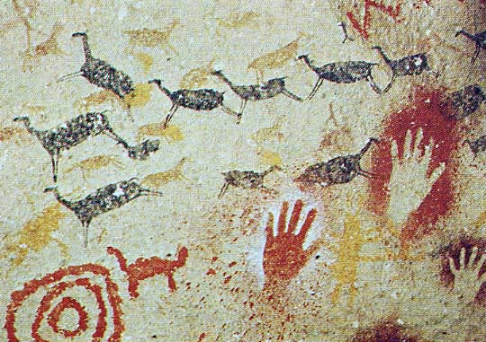
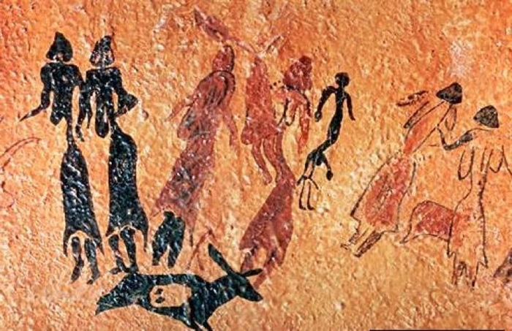

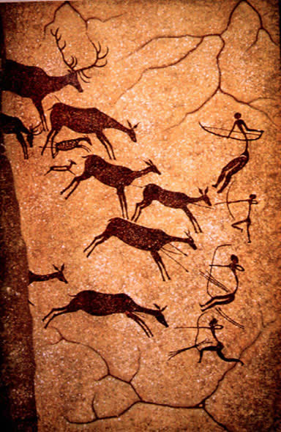
Was it simple artistic expression? Was it preserving a memory? Was it telling a story? Was this the only way these people had to communicate? Again, we will probably never know. But the urge to communicate is strong in humans.
From these primitive yet powerful drawings, we developed better ways to share ideas. Correspondingly, some of our earliest written languages are pictographic. That is, the “words” are really just pictures of what they represent. Early Egyptian Hieroglyphs and Totem poles are examples.
Similarly, those lines we learned to draw became more abstract written languages. Ancient Peruvians sent beans with dots and slashes carved on them as messages. Another Incan method is Quipu, a method that encodes information using a series of knotted cords, which is really just lines with dots in three dimensions.
As with our oral traditions, these early methods of language still exist today, albeit less frequently; we still paint, draw, and carve.

Abstraction
Pictures are a powerful way to convey meaning but as with Chinese and Egyptian pictographs, you may need 1,000s of them to express many complex ideas. This leads to a fundamental limitation; if you don’t know what the thing is or represents, you don’t know what is being said.
However, alternative forms of written language have developed. One of our earliest written languages is cuneiform, a series of wedge shaped impressions used to form numbers and words.
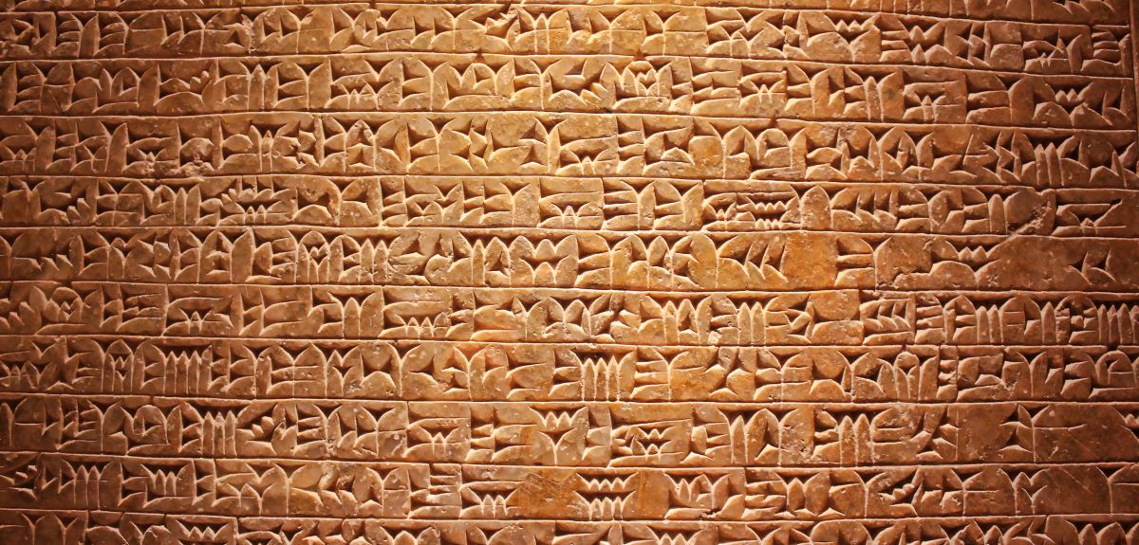
The Sumerians developed this language and, as far as we can tell, cuneiform came from accounting practices. In my History of Cheese class, I discuss this further, but will summarize it here. The Sumerians had a temple economy, and as pastural people, they made a lot of cheese products. Excess cheese would be stored in temples for times of need. But how did you know how much was stored in the temple? And what was it? Writing was the method established to keep track of this.
For Europe and Near Asia, the methods of shaping cuneiform characters using a stylus pressed into clay greatly influenced how language was written. As wet clay is pretty unforgiving and the reed stylus doesn’t easily make curves, straight lines are the best option. On the other hand, writing in clay had several advantages. In the wet stage, it was pretty easy to write on. Clay itself was plentiful and cheap. Once fired, it was durable and semi-portable. Still clay as a writing surface had limitations, as it was not 100% portable all the time and was prone to breaking given enough stress.
Although the Phoencians learned to write from the Sumerians, their language had evolved to be phonetic. This reduced the number of character options, as you only needed one symbol per sound. However, this script was still made of mostly straight lines.

Papyrus
Now we move on to where paper gets its name, but the two things are not the same. The papyrus reed has a triangular stalk and is a structured bit like an onion or leak. The inner layers are interconnected, form a tight spiral, and can be cut apart. The resulting lengths of papyrus were laminated to each other at 90 degrees to each other and many sheets would be joined together to form scrolls. We have papyrus scrolls dating back to ~2,800 BCE.
The most important thing about papyrus as related to the development of writing is that it was traded. Although the papyrus reed was generally a fast growing plant, only few sections of the Nile had growing conditions suitable to obtain the best stalk thickness to get usable material from it. Papyrus was traded throughout the Mediterranean, and the Egyptians controlled the manufacturing process. Overall, papyrus was a good writing material. It was much easier to write on papyrus than on clay or stone. Properly sized, papyrus allowed for good ink flow and letterforms could use more strokes than simply straight lines.
Writing on this kind of material is not unusual and many cultures developed similar ideas. The Chinese first wrote on bamboo splits. The Polynesians made a similar writing surface from palm bark. It is possible that Mayan “paper” was more like papyrus, but evidence is inconclusive as to the exact nature.

Parchment
Although papyrus was a satisfactory writing surface, it was expensive and the Egyptians kept a tight control over it. When Eumenes of Pergamum wanted to build a rival library to Alexandria, Ptolemy, the Egyptian pharaoh, did not want to supply papyrus to his rival. Eumenes looked for another alternative and found Pergamum, or parchment, scrapped hide from young animals. Thin, supple, and smooth, it became the material of choice for Europe. Like papyrus, it was labor intensive to make; unlike papyrus, it was very durable, especially outside of desert climes, and could be made into codices.
The Romans had codices for a while, in that they bound their wax tables into “books”, creating a codex. Generally, a codex was much easier to reference than a scroll, where information could be found on a particular page instead of unwinding a scroll to search for a particular passage. Wax tables, however, are temporary writing surfaces. Parchment allows for a more permanent book.
This means that in Europe, for the better part of 1,000 years, parchment was the king of writing materials. Even though the ink could be scrapped off, parchment meant permanence. But for the world as a whole, and later Europe, parchment was not enough. It was expensive, it took time, and didn’t hold up to a later invention. We will discuss this more later.

Paper

Chinese
Around 100 CE, a Chinese monk was tasked with developing a writing surface; what would become paper. Or at least that is the legend. No one really knows who actually invented paper or exactly why. At this point in Chinese history, it was felt that more and more documents needed to be kept and things like receipts for purchase, tax records, imperial decrees, and religious prayers needed to be written down. While silk, which had traditionally been used for a writing surface, was “cheap” in China, it was still not cheap enough nor could be produced fast enough to meet this increased demand.
It was likely a product of a longer history of experimentation, but between 100 CE and 300 CE, China started producing good quality paper. This development was so significant that paper is one of the four Chinese inventions that changed the world. Generally, this type of eastern paper was often made from mulberry bark, but linen and hemp were also used. However, paper was also made from specific materials for specific reasons: rattan for official edicts, mulberry for art pieces, and grass blends for cheap stock. After a few hundred years, a poisonous additive was also included to kill insects that liked to eat paper.
Paper could be made quickly. I don’t have information on how long it takes to make the early writing surfaces, however hundreds to thousands sheets of paper could be made per day. All that was needed was a source of fibers and water, which were cheap and plentiful materials. Since this process was so effective, paper was used in many ways: to write on, to wrap things, as garments, as lanterns, as toilet paper, as towels, and more. Sizing also mattered; if it was unsized, it was absorbent but if sized, it could be written on.
As Chinese culture spread, so to did paper. In the 3rd century CE, China imported nearly 40,000 rolls of various paper from Vietnam, in addition to domestic paper production. The Chinese needed a lot of paper and the Vietnamese were good at making it.
Buddhism in particular is responsible for the spread of paper through Asia as it is a sacred art to write or draw the sutras. As Buddhism spread through China, Korea, and to Japan and beyond, paper moved with it. However, while India is the birthplace of Buddhism, native papermaking came pretty late to this country. It is not until the 7th century CE that we find native Indian paper. It is also in this region that another major culture adopts paper, the Muslims.

Islam
The legend goes that when the Muslims conquered Samarkand in the mid 700’s, they captured Chinese papermakers and learned the secret of paper from them. However, we have archaeological evidence of a packet of letters from Central Asia around 300 CE sent from an angry wife to her to wayward husband. She writes, “I would rather be a dog’s wife or a pig’s wife than yours.” So paper was used in Central Asia well before Islam arrived but again it is the religious needs of Islam that sparked the need for paper. As is common, they made adjustments to the process to fit their accessible resources.
The Muslims made paper from used linen rags, using rice or wheat starch to size the paper. Even though they were a desert culture, they used water wheels to drive their paper mills. Like Buddhism, writing is a sacred act in Islam for Allah gave mankind the quill with which to write. Calligraphers and scribes have high standing in the Islamic culture, and, with the prohibition of human figures, beautiful writing became a form of art.
As the Caliphates expanded across Northern Africa and Southern Europe, more paper mills came online. The Arabs did have access to papyrus and parchment but as they had literate society and a large, legalistic empire, neither of these items could be produced fast enough or in large enough volume to meet demand. Words on paper were also permanent in that you couldn’t just scrap off the ink.
For a period of time, fine Arabic papers were imported into Europe. However, in Norman Sicily and other places, policy became that official decrees must be on parchment. Was this a reaction against Islam? Not likely in the case of Norman Sicily, but possibly.
The Arabs were keen gatherers of knowledge. Their rulers wanted huge libraries to rival Alexandria of old. For example, around 900 CE, a large European library in Switzerland had ~400 books. Arabic private libraries had thousands of books. Places like the House of Wisdom in Baghdad had around 100,000 books. As another example, the library in Cordoba had ~400,000 books. Conversely, it took the Vatican Library until 1455 to have 5,000 books.
Telling, it is an Arabic word we use in English today to describe a bundle of paper, a ream. It meant then what it does now, 500 sheets of paper.

Europe
As Europe pushed the Muslims out, they gained many innovations, paper amongst them. But it was a slow conversion as paper was initially seen as a product of Moors and Jews and not heavily favored. Italy and Spain were generally happy to buy paper, but it wouldn’t be until the 12th century that Europe was making its own paper since they often used former Islamic paper mills. The first verified, native paper mill in Europe is in Fabriano, Italy. At the same time, converting felting mills to paper was very successful.
The Europeans also changed how paper was made. Linen rags were still the most popular source of fiber, but the sizing was changed to a glue made from animal gelatin. Trip hammers pounded the mash and wire moulds were used to cast the paper. As a result, paper was very cheap. As an example, one Bible written on parchment needed ~250 sheep and over a year to write, while enough paper for one Bible could be made in week. Also, with the wire mould, the Italian paper industry introduced the idea of the watermark. Paper now had a brand.
Branding was important so you could know who made the paper. The watermark is of a jester’s hat. In the increasingly crowded market of Renaissance Europe, you wanted to distinguish your product from a competitors. Paper came in different quality and different purposes. Watermarking allowed for easy identifcation. If we look at Shakespeare for instance, in some of the plays, a character calls for a piece of foolscap. This is a brand of paper.
Northern Europe would demand paper as the printing press came into being. This explosion of the written, really printed word, meant that animals simply could not be killed fast enough to satisfy the need for a substance to print on.
As we close out the 1600s, paper has spread everywhere in Europe and Asia. The introduction of the moveable type press meant that words could be printed and distributed quickly, and cheaply. Paper was so cheap you could make notes on it to throw away or wrap purchases in it. And importantly, society was literate enough that they wanted things to read.
All of the other methods of preserving writing and knowledge still existed, as for example, we still carve things into stone today. But by this time it was clear paper had become king.

