Lucretia’s Fused Roman Mosaic Bowl –
based on 2017 Midlands Regional Arts and Sciences Faire, Division 4 Glasswork (possibly stained or other)
Oswyn of Baðon of Shire of Wurmwald
mka Sean Wilson (oswyn969@gmail.com)
By Oswyn of Baðon

Introduction
This type of glass bowl dates back to the early Imperial Period in Roman History [1]. Below are pictures of some existing finds of Roman Mosaic bowls. These types of bowls are very common finds.
- 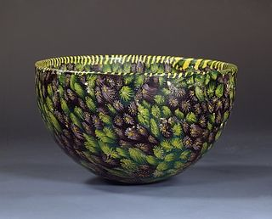 b. 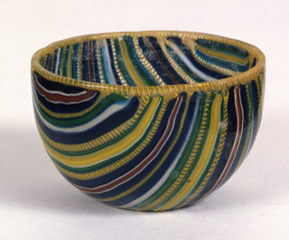
- 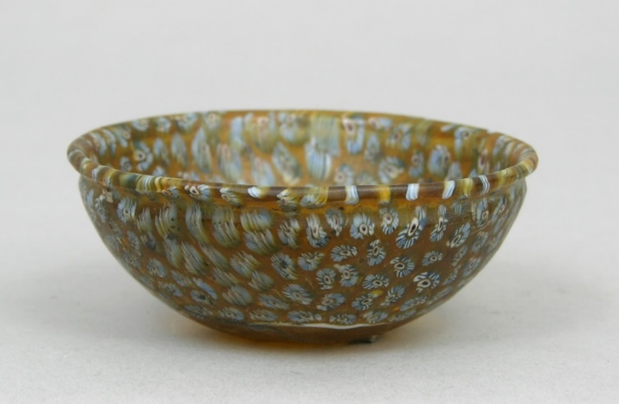
The Roman glass industry [2] was wide spread in the late Republic and early Imperial periods. This type of glass work is called cast glass or sometimes mosaic glass. Later, glassblowing becomes more popular as it is easier and allows for greater variety of shapes and designs. Cast glass falls out of favor.
The making of glass and the working of glass were most often done in separate locations. Roman glass was made close to the sources of the raw materials. The two sites that are known about are Bet She’arim (near Haifa Israel) and Bet Eliezer (near Hadera Israel) [3]. Nearly all Roman glass is made of the same substances, silica sand, soda, lime, and then additives.
Working of glass though could happen almost anywhere. With the mixture shown above, temperatures of only ~750 o C were needed to work glass. This could be achieved in clay ovens similar to these below [4].
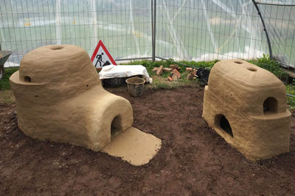
We have no technical handbooks on how the Romans actually worked their glass [2]. There are snippnets of information in Pliny and Martial. More information can be gleaned from later Italian works (~15th c) and experimental archaelogy have shown what methods they must have used. In many ways, hand worked glass has not changed that much from medieval times to now. What the tools were made of and where the heat comes from have evolved, but the basic methods are very similar to older times.
There are several methods that the Romans used to make these cast bowls. One method uses sections of glass rods and scrap glass applied to a round mold. Another mold is pressed over it and the pressure between the two bowls pushes the glass together. The second method is to take sections of a glass rod and make a flat plate. The plate is then slumped over a single mold. Lastly, strips of glass are cut to make a plate and that is slumped. After this, cast glass goes out of fashion. Fused canes become more popular and then blown glass over takes both methods.
For your bowl, I am attempting to replicate the third method. This is probably how the bowl labelled b above was made. I have cut strips of fuseable glass, adhered them to a clear glass circle, and fused the whole thing into a plate. That plate is then slumped over a mold to make the bowl.
For my pent, I tried to replicate the second method. This process is probably what made bowls a and c and is more complicated than the third method [5]. The process is similar to the Venetian millefiori process from 18th century Venice. In this process, a core of glass is heated to make a rod at the end of a metal rod. The glass core is then dipped into other colors of glass to add layers of color and patterns to the glass core. It can be straight colors or the rod can be twisted to add swirls to the colors.
Once cooled, the multi-colored glass rod is cut into discs and those discs are then arranged into a plate, the plate fused, and then slumped over a pre-cast form.
They also would have used saws to cut the glass rods. They would have used heated groziers to cut the glass.
The Roman methods are what we call a “hot” glass methods. The oven is an open heat source and the glass can be introduced to the heat at any time. They would have used some “cold” glass techniques as well. As I have no access to a hot glass workshop, I am trying to replicate both bowl using only cold or warm glass techniques. It does present special challenges.
The making of the actual glass is very different from ancient times to now. I do not have the ability or access to the equipment to make my own glass. Also, as most colors in glass arise from heavy metals, I do not have the environmental clearances to make glass, even if I desired to.
I use a modern silicon-carbide glass cutter to cut my glass and I am using a modern electric kiln to fuse and slump my glass. But the process is pretty much the same, even with the differences in equipment. Both the Romans and I have to cut the glass, make the millefiori, fuse the plate, and slump the plate. Both of us are using a cutting instrument (romans heat, me disruptive surface tension). Both of us then need a heat source (Romans wood or charcoal, me electricity). Both of us make a plate and slump over a pre-cast form.
Process for my Pent
First, I had to plan the pattern. I chose to make a pattern based on my device colors and on a tablet weaving pattern that I am using as a badge.
- 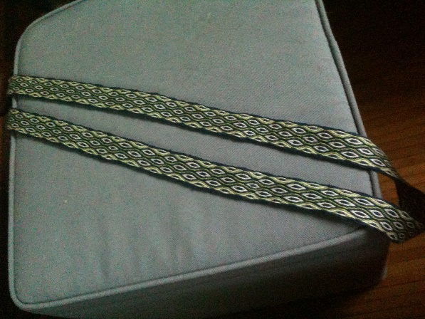

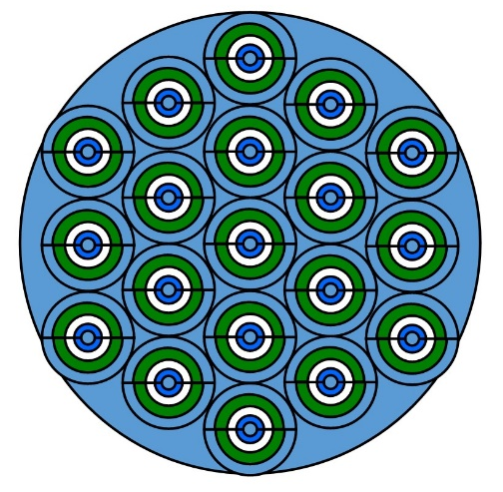

I wanted to make a bowl ~5 inches in diameter. I needed to then calculate how to make the “millefiori” discs of ~1 inch diameter. I needed to calculate the length of glasses needed to make a 1” diameter at the end. 2πr is the circumference of a circle and r=0.5” in this case. Also, I was going to make half-circles so a=π0.5. The outer layer needs to be 1.6”. The next layer is 1/8” less in radius and then next 1/8” less again, and the last 1/8” less again. B therefore equals 1.1”, c equals 0.79” and d equals 0.4”.

Light blue is a
Green is b
White is c
Dark blue is d

From the pattern, I needed 19 full circles. So, 38 half-circles and each half-circle 0.375” in thickness. I needed to make a rod ~14.25”. I cut flat panels of glass of the appropriate colors to the width listed above (a through d) and 14.25” long. I then stacked these strips with d on the bottom and fused them into a rod. This allowed the longer pieces to slump over the shorter ones to make a half-circle.

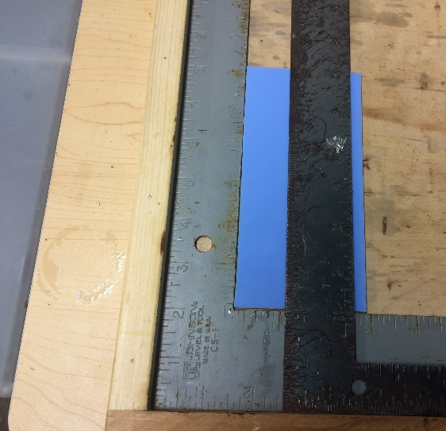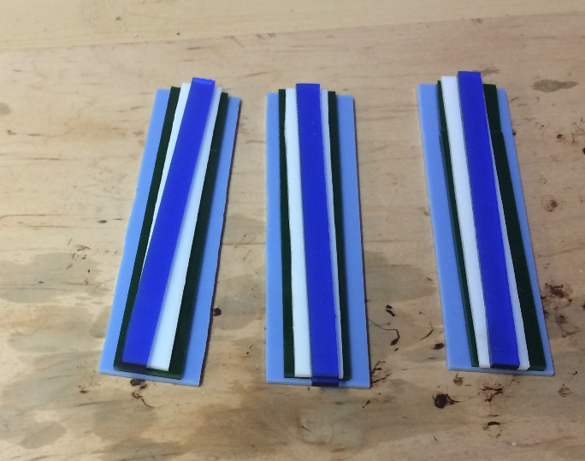

Example of measuring the glass to cut. Cut glass stacked, waiting to be glued before fusing

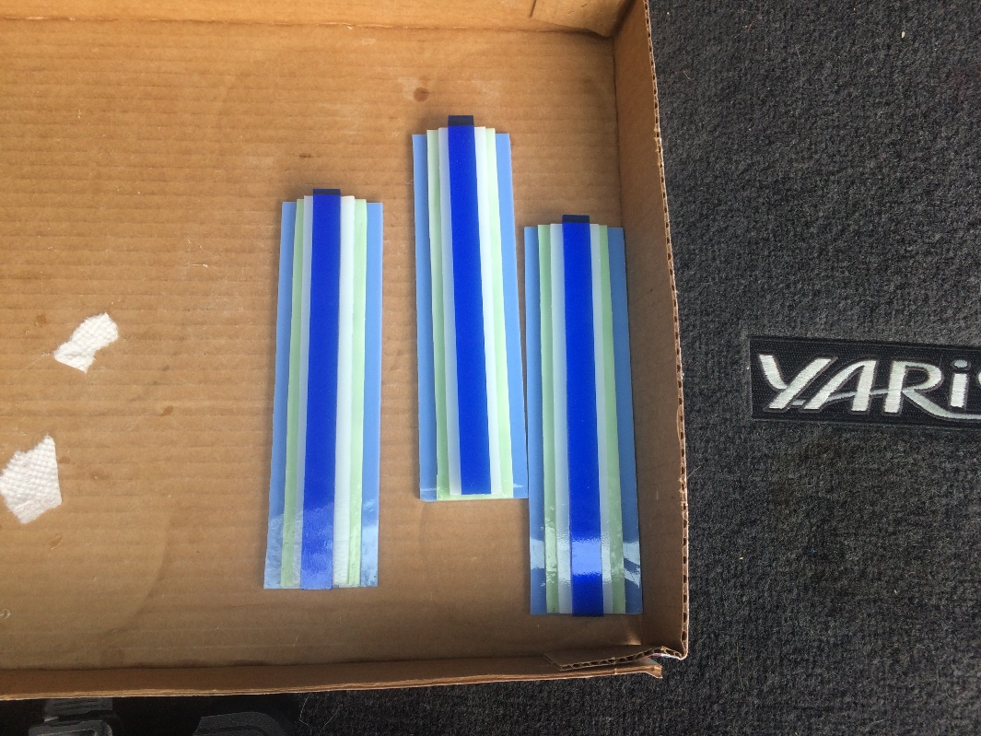
Glass glued together before fusing into a rod

The 0.375” is important. Glass likes to be ~0.25” thick due to surface tension. Cutting to 0.375” gives enough extra glass so that it will fill in the void spaces.

I then used a tile saw to cut 0.375” thick portions of the rod and arranged those discs into the pattern above.

My first round fusing the rod in the kiln revealed an error in my assumption. I believed the wider glass would slump over the thinner glass and form half circles. However, again due to surface tension, the wider glass just spread out, giving more of a raised mound type shape rather than half circles. I decided to just use it.
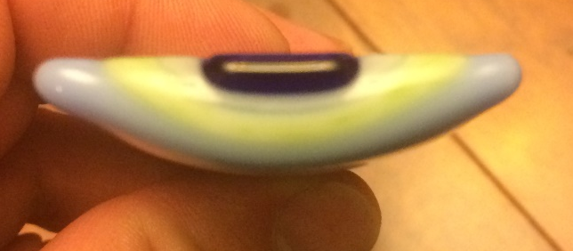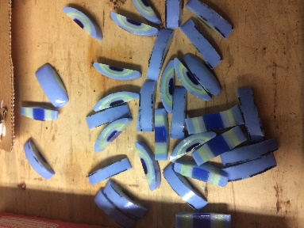
Cross section view of the slumped rods rods cut into half circles
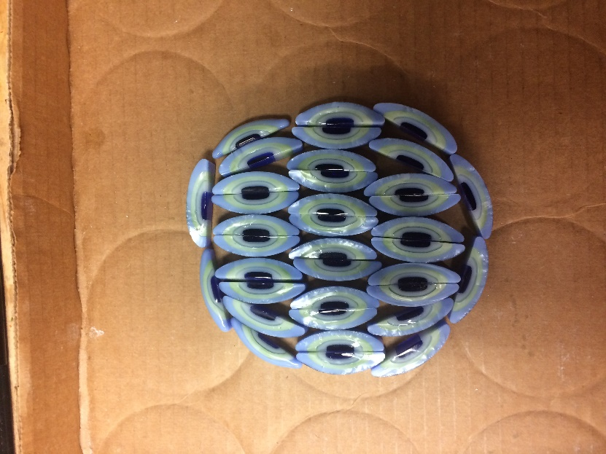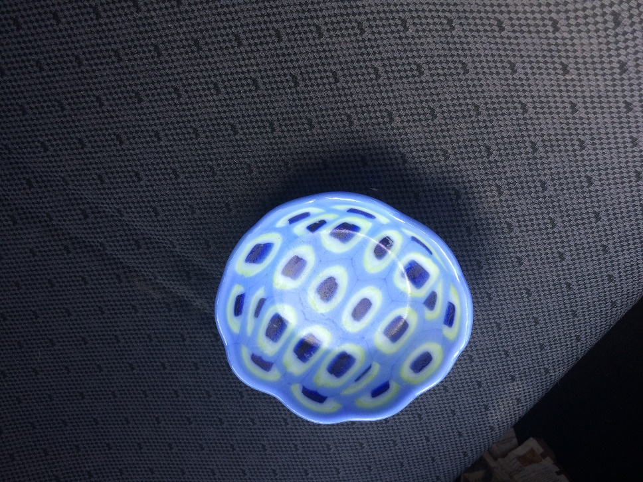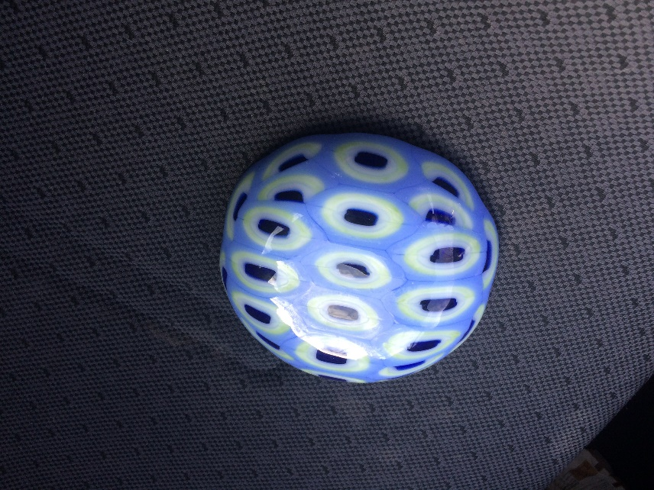
Half circles arranged for the plate Finished bowl inside and out
Process for your bowl

First, I had to plan a pattern. I obviously changed my mind a bit once I bought the glass but the theory remains the same. I cut 0.5” strips of various lengths to fit a 9” plate.

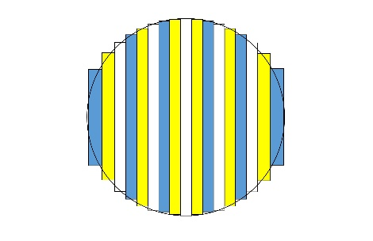 | 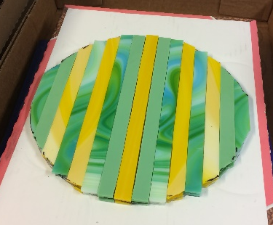
Pattern for Lucretia’s bowl | Cut strips laid out

I wanted the “pattern” to be visible on both sides of the bowl. Even though this will be a shallow bowl, if someone picked it up, I wanted the “movement” of the glass to be seen. The glass I had access only had a pattern on one side so that meant cutting two sets of strips. I adhered one set to the “top” of the clear glass circle. Once that dried, I adhered the second set to the other side of the clear glass circle. The patterns won’t match exactly but I think it will be cool.

At the shop, I discussed with the owner about whether I should have adhered the two sets of strips to each other perpendicularly. That also might have been cool and I try that in the future.

Next, I took the plate to my local glass shop where they fused the plate in the kiln and then slumped it over the bowl mold. On the upper right side, you can see a “white” strip on the edge. The best I can guess is either the shop or I accidentally glued this strip upside down when it came loose. Sorry about that.

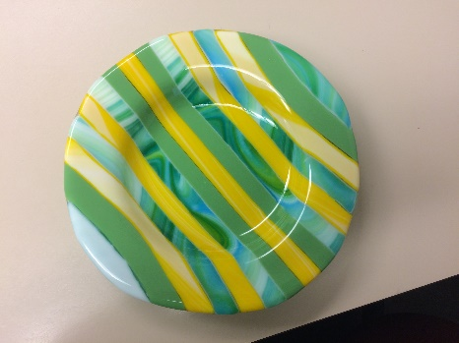 Final product

Materials
For fused glass, it is important to match the COE so that the glass expands and contracts at the same rate. I used Spectrum 96 COE glass for this purpose. As far as we know, the Romans had no idea of COE though since much of their glass was made of the same ratios of the same raw materials, it is likely that the COE’s were very similar.
As stated above, I used a modern pistol grip silicon carbide glass cutter to cut the glass. I paid to use my local glass stores electric kiln to do all of my fusing and slumping.
References
[1] http://www.toledomuseum.org/kiosk/ancient-asian-european-glass/ancient-glass/pivotal-moments-in-ancient-glass/fused-and-slumped-mosaic-glass-bowls-greco-roman/
[2] Fleming, S. J., 1999. Roman Glass; reflections on cultural change. Philadelphia, University of Pennsylvania Museum of Archaeology and Anthropology. p. 10
[3] Fleming, S. J., 1999. Roman Glass; reflections on cultural change. Philadelphia, University of Pennsylvania Museum of Archaeology and Anthropology. p. 11
[4] http://archeoglas.glasofenexperiment.de/index-en.html
Roman Furnace Project 'Borg Furnace Project' (BFP)
The first project ARCHEOglas will cover is the reconstruction of a Roman glass workshop based on an excavation in Trier (Hopfengarten), which was buildt in the Archeological Park Roman Villa Borg (Saarland / Germany). The furnaces were fired in October 2013 for the first time.
[5] Allen, D., 1998. Roman Glass in Britain. Princes Risborough, Buckinghamshire, Shire Publications.

